More Exciting Stoichiometry Problems!

Answer the following stoichiometry-related questions:

1) Write the balanced equation for the reaction of acetic acid with aluminum hydroxide to form water and aluminum acetate:

2) Using the equation from problem #1, determine the mass of aluminum acetate that can be made if I do this reaction with 125 grams of acetic acid and 275 grams of aluminum hydroxide.

3) What is the limiting reagent in problem #2?

4) How much of the excess reagent will be left over after the reaction is complete?
More Exciting Stoichiometry Answers!

1) Write the balanced equation for the reaction of acetic acid with aluminum hydroxide to form water and aluminum acetate:

3 C₂H₃O₂H + Al(OH)₃ → Al(C₂H₃O₂)₃ + 3 H₂O

2) Using the equation from problem #1, determine the mass of aluminum acetate that can be made if I do this reaction with 125 grams of acetic acid and 275 grams of aluminum hydroxide.

Two calculations are required. One determines the quantity of aluminum acetate that can be made with 125 grams of acetic acid and the other determines the quantity of aluminum acetate that can be made using 275 grams of aluminum hydroxide. The smaller of these two answers is correct, and the reagent that leads to this answer is the limiting reagent. Both calculations are shown below – the correct answer is circled.

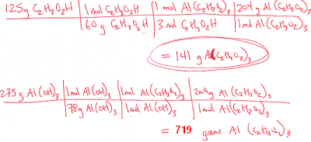

3) What is the limiting reagent in problem #2?

Acetic acid.

4) How much of the excess reagent will be left over after the reaction is complete?

